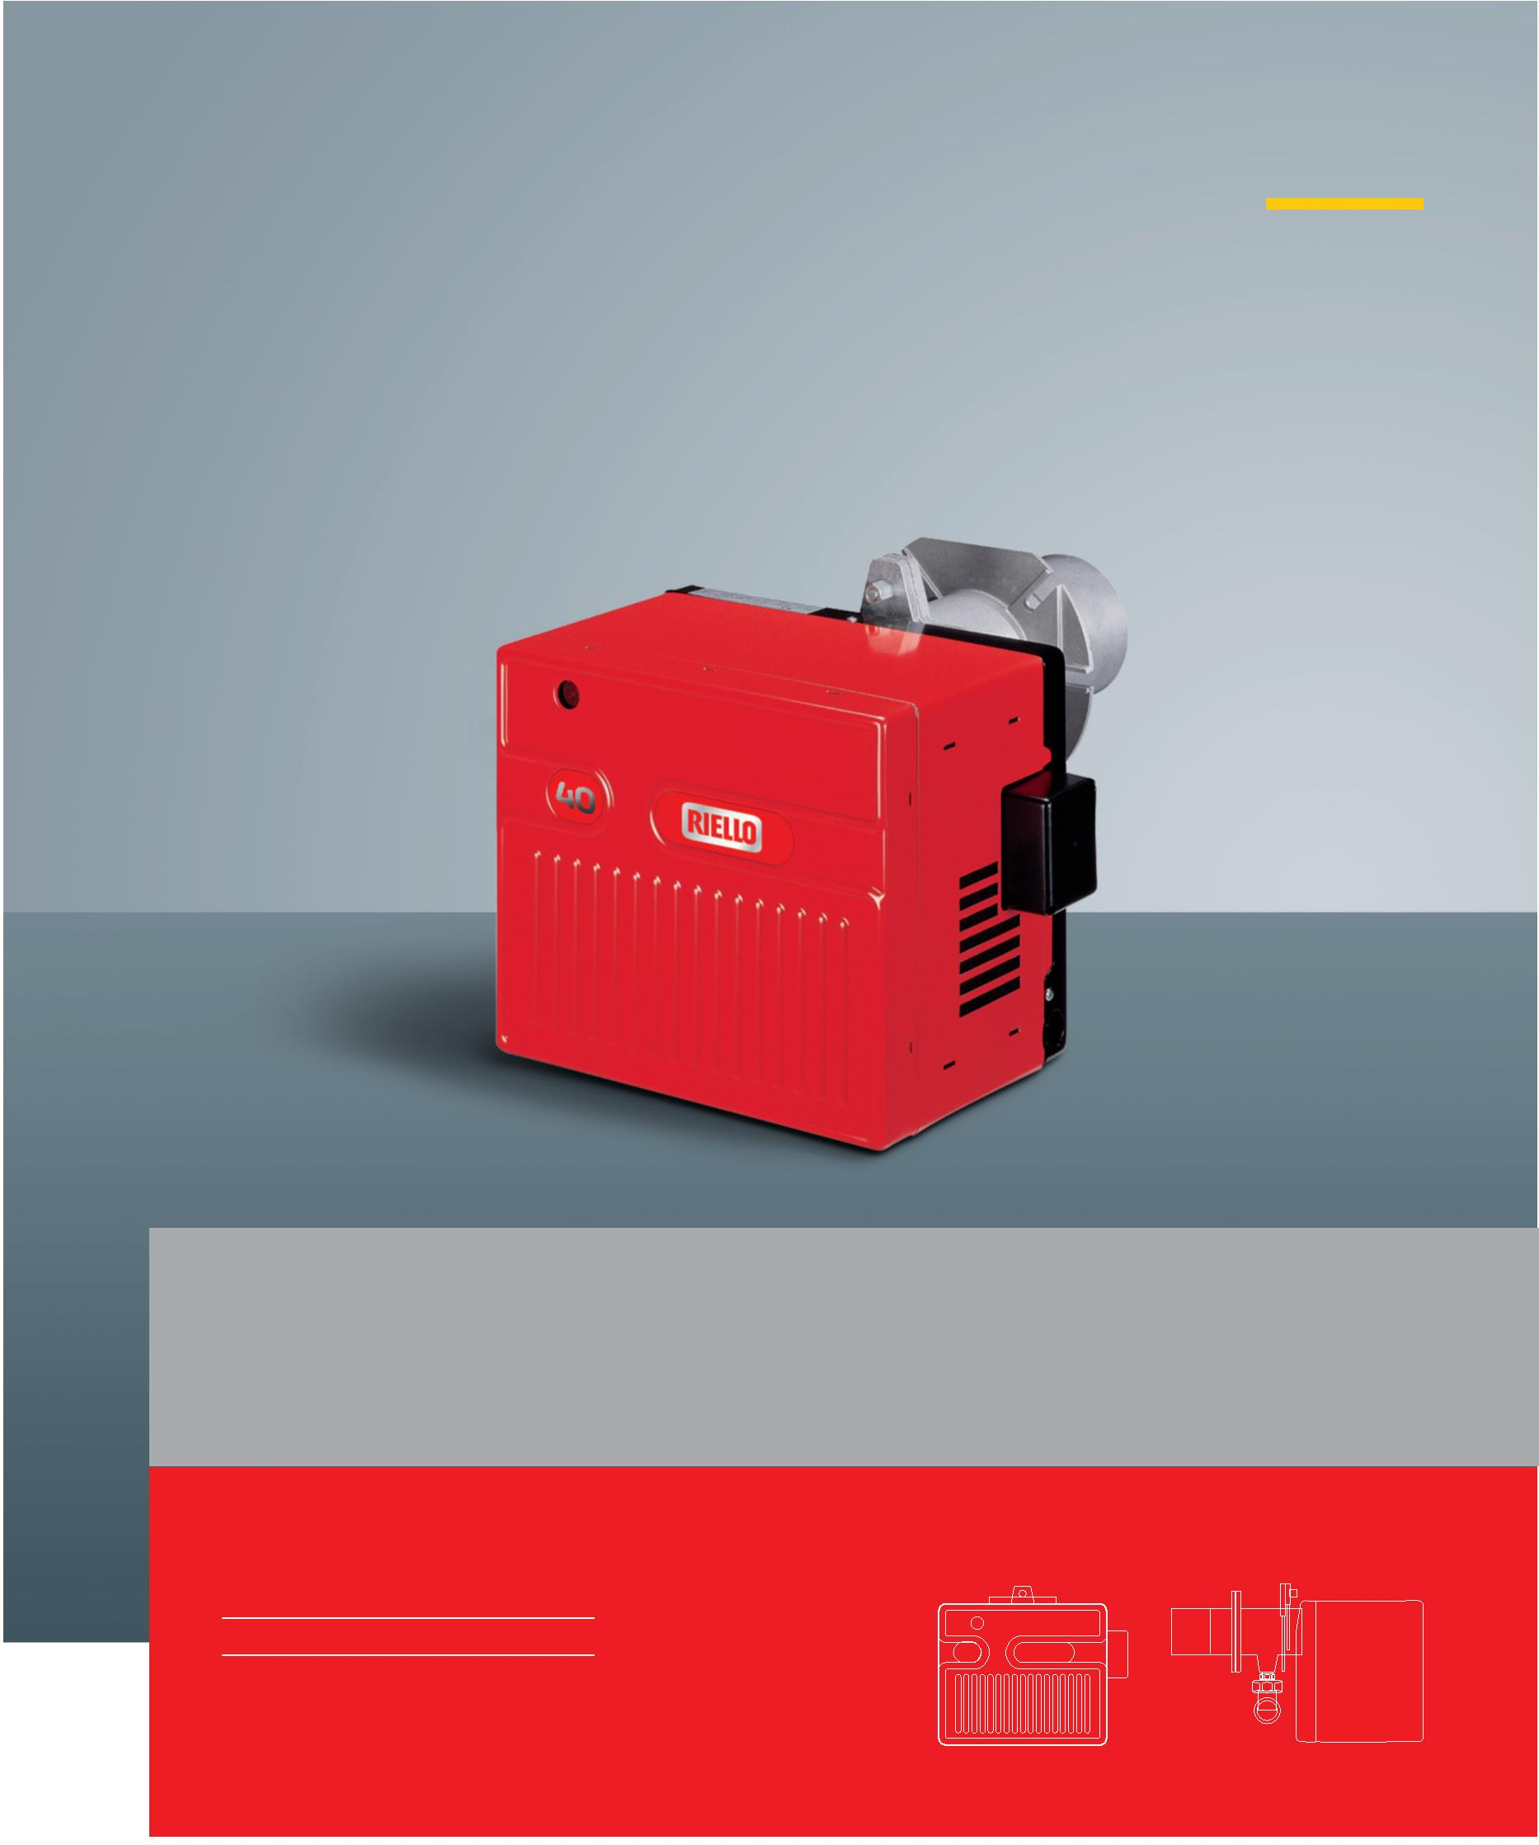TECHNICAL DATA LEAFLET GAS
Riello 40 FSD Series Two Stage Gas Burners
FS5D 12/23 ÷ 58 kW
FS20D 58/81 ÷ 220 kW
www.riello.com
Two Stage Gas Burners FSD 5 ÷ 20 Series
The Riello 40 FSD series of one stage gas burners, is a complete range of products developed to respond to any request for light
industrial application. The Riello 40 FSD series is available in five different models, with an output ranging from 11 to 220 kW,
divided in four different structures.
All the models use the same components designed by Riello for the Riello 40 FSD series. The high quality level guarantees safe
working.
The Riello 40 FSD burners are fitted with a microprocessor - based control box, with diagnostic functions.
In developing these burners, special attention was paid to reducing noise, to the ease of installation and adjustment, to
obtaining the smallest size possible to fit into any sort of boiler available on the market. All the models are approved by the EN
676 European Standard and conform to European Directives for EMC, Low Voltage, Machinery and Boiler Efficiency.
All the Riello 40 FSD burners are tested before leaving the factory.
2
Technical Data
MODEL FS5D FS20D
Burner operation mode Two stage
Modulation ratio at max. output ===
Servomotor type R.B.L BERGER
run time s 12/23 ÷ 58 58/81 ÷220
Heat output kW 10/20 ÷ 50 50/70 ÷ 189
Mcal/h 9.5 ÷ 30 20 ÷ 50
Working temperature °C min./max. 0/40
FUEL/AIR DATA
G20 gas net calorific value kWh/Nm³ 10
gas density kg/Nm³ 0.71
gas delivery Nm³/h 1.2/2.3 ÷ 5.8 5.8/8.1 ÷ 22
G25 gas net calorific value kWh/Nm³ 8.6
gas density kg/Nm³ 0.78
gas delivery Nm³/h 1.4/2.7 ÷ 6.7 6.7/9.4 ÷ 25.6
LPG gas net calorific value kWh/Nm³ 25.8
gas density kg/Nm³ 2.02
gas delivery Nm³/h 0.4/0.8 ÷ 2.2 2.2/3.1 ÷ 8.5
Fan type Centrifugal with forward curve blades
Air temperature max °C 40
ELECTRICAL DATA
Electrical supply Ph/Hz/V 1/50/230 (±10%)
Auxiliary electrical supply Ph/Hz/V ===
Control box type MG 557/3 RMG 88.62C2
Total electrical power kW 0.110 0.250
Auxiliary electrical power kW ===
Protection level IP X0D
Fan motor electrical power kW 0.09 0.15
rated current A 0.65 1.4
start up current A 2.6 5.6
protection level IP 20
Ignition transformer type Incorporated in the Separated from the
control box control box
V1 - V2 (-) - 8 kV 230 V - 8kV
I1 - I2 (-) - 12 mA 1.8 A - 30 mA Operation Intermittent (at least one stop every 24 h)
EMISSIONS
Noise levels sound pressure dB (A) 60 73
sound power W ===
Gas G20 CO emission mg/kWh < 40
NOx emission mg/kWh ≤ 120 APPROVAL
Directive 2006/42/EC - 2009/142/EC - 2014/30/UE - 2014/35/UE
Conforming to EN 676 - EN 12100
Certification CE-0694CN7805
Reference conditions:
Temperature: 20°C - Pressure: 1013.5 mbar - Altitude: 0 m a.s.l. - Noise measured at a distance of 1 meter.
Since the Company is constantly engaged in the production improvement, the aesthetic and dimensional featu-
res, the technical data, the equipment and the accessories can be changed. This document contains confidential
and proprietary information of RIELLO S.p.A. Unless authorised, this information shall not be divulged, nor du-
plicated in whole or in part.
3
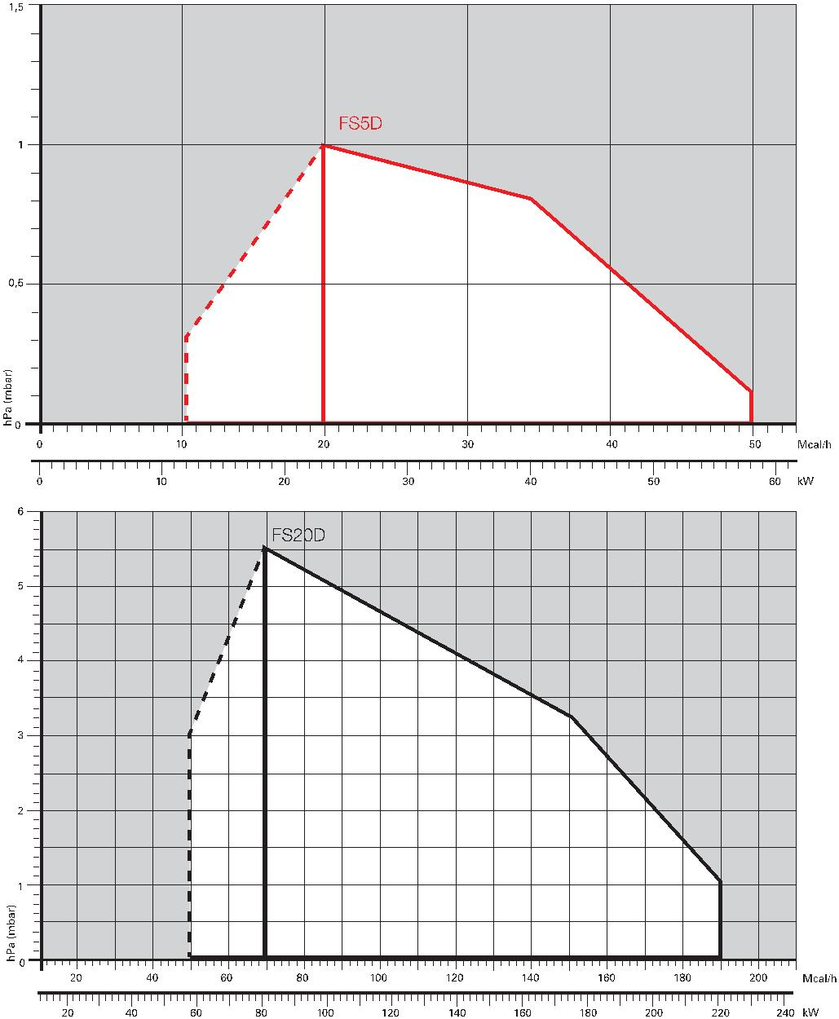Two Stage Gas Burners FSD 5 ÷ 20 Series
Firing Rates
Useful working field for choosing the burner
1st stage operation range
Test conditions
conforming to EN676
Temperature: 20°C
Pressure: 1013.5
mbar Altitude: 0 m
a.s.l.
4
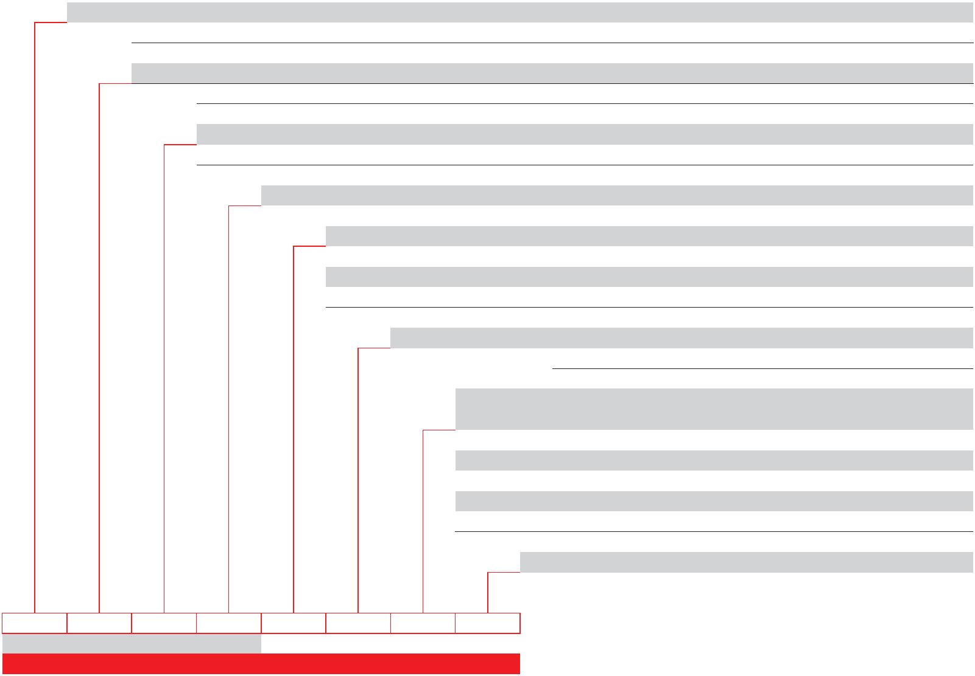Gas train
GAS TRAIN DESIGNATION
Series: MB
MBC
Size: 405 407 410
65
Operation: /1 stage mode opening
/2 two stage mode opening
Leak detection control: - 0
Joint type: R threaded joint
F1 square flange BS1
F2 square flange BS2
F3 square flange BS3 - BS4
Electrical connection: SD Domestic plug
T Terminals - Terminal strip
 | Standard output  pressure range: |  | - without pressure governor
0 with governor and air/gas proportional pressure
2 with governor and output pressure up to 20 mbar
3 with governor and output pressure up to 30 mbar
4 with governor and output pressure up to 40 mbar
5 with governor and output pressure up to 50 mbar
Valve control: 0 shared
MB 407 /2 - R SD 2 0
BASIC DESIGNATION
EXTENDED DESIGNATION
5
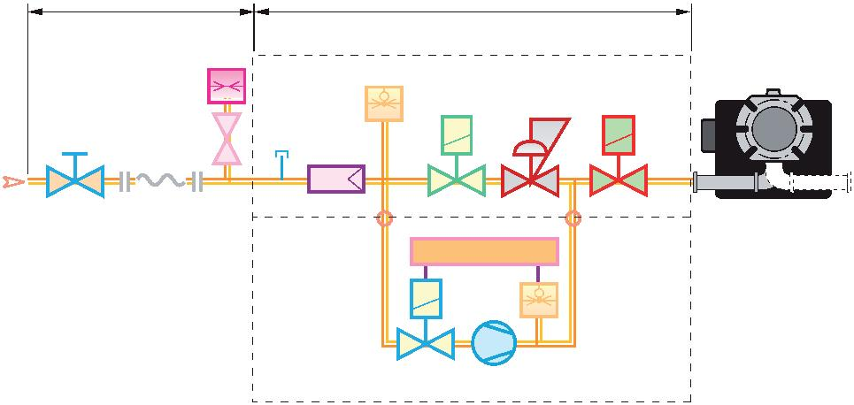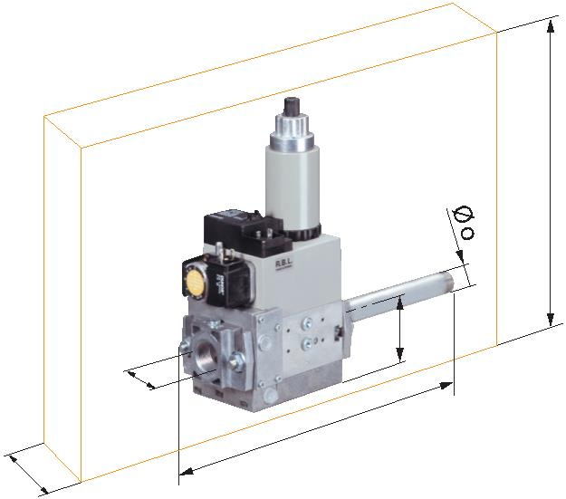Two Stage Gas Burners FSD 5 ÷ 20 Series
GAS TRAINS
The burners are set for gas supply from either the right or left hand sides.
Depending on the fuel output and the available pressure in the supply line, you should check the correct gas
train to be adapted to the system requirements. The gas train is Multibloc type, containing the main components
in a single unit and it can be fitted with the valves seal control (as accessory).
MB 405-407-410
L1 L 1 Gas input pipework
 | 2  1 3 |  |  |  |  | 4 |  |  |  |  | P2 |  |  |  | 5 |  | 6 |  |  |  | MULTIBLOC  7 9 8 |  |  |  |  |  |  | P1 |  |  |  | 2 Manual valve (charged to the in-  staller)  3 Antivibrating joint  4 Gas pressure gauge  5 Gas filter
 |  |  |  |  |  |  | 10 |  | LEAK DETECTION CONTROL DEVICE |  |  |  |  |  |  |  |  |  |  |  |  |  |  |  |  | 11 |  |  |  | 12 |  | 6 Min. gas pressure switch  7 Safety gas valve  8 Adjustment solenoid: 1st and 2nd  stage:firing delivery adjustment  (rapid opening)  maximum delivery adjustment  (slow opening)  9 Pressure regulator  10 Leak detection control device for val-  ves 7 and 8 (accessory)  11 Gas train-burner adapter  12 Burner  13 Shutter with adjustment screws  14 Pressure regulator setting device  15 Regulation solenoid  P1 Combustion head pressure  P2 Upstream pressure from the filter  P3 Upstream pressure from the control  valve
 |  |  |  |  |  |  |  |  |  |  |  |  |  |  |  |  |  |  |  |  |  | Y |  |  |  |  |  |  |  |  |  | L Gas train supplied separately  L1 Installer’s responsability
 |  | Z |  | Øi |  |  |  |  |  |  |  |  | X |  |  |  |  |  | W |  |  |  |  | The dimensions of the gas trains vary depending on their  construction features.  The following table shows the dimensions of the gas trains  that can be fitted to Riello 40 FSD burners, intake and outlet  diameters.
GAS TRAIN
MODEL CODE Ø in Ø out X mm Y mm W mm Z mm
MB 405/2 3970084 Rp 1/2” Rp 1/2”(*) 321 257 46 120
MB 407/2 3970537 Rp 3/4” Rp 3/4” 371 257 46 120
MB 410/2 3970534 1” Rp 3/4” 405 315 55 145
(*) With 1/2” - 3/4” reduction nipple supplied.
6
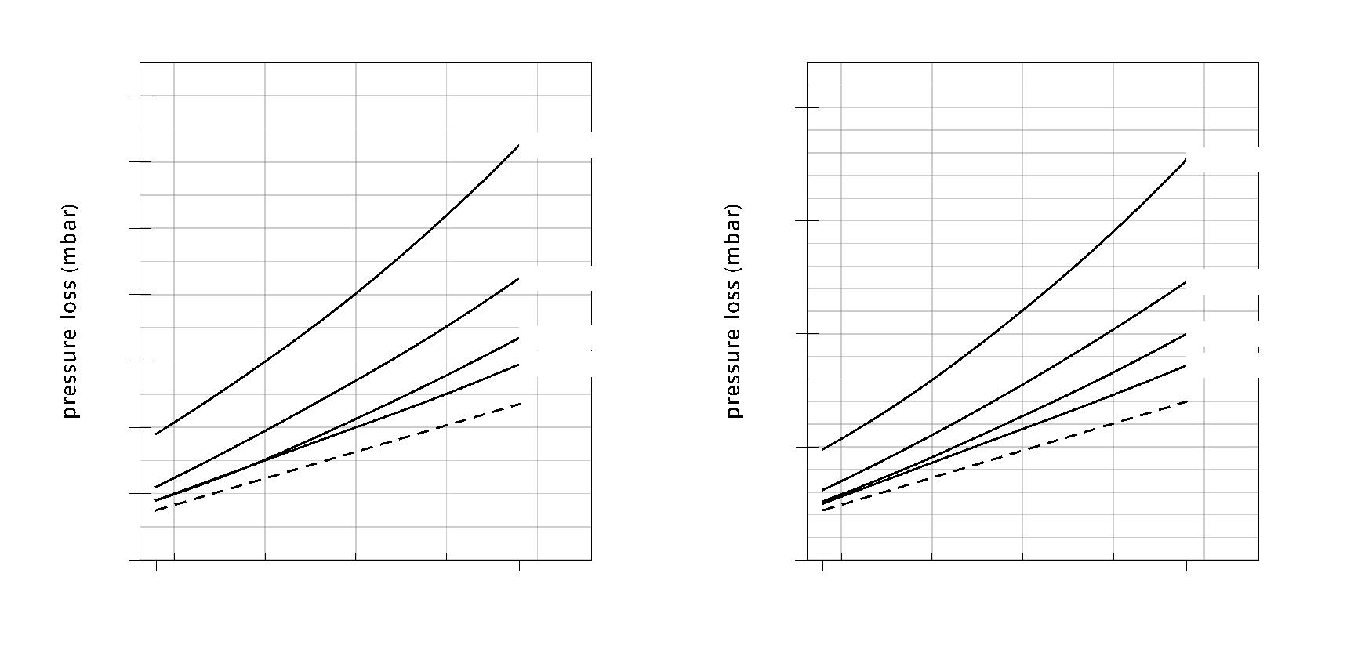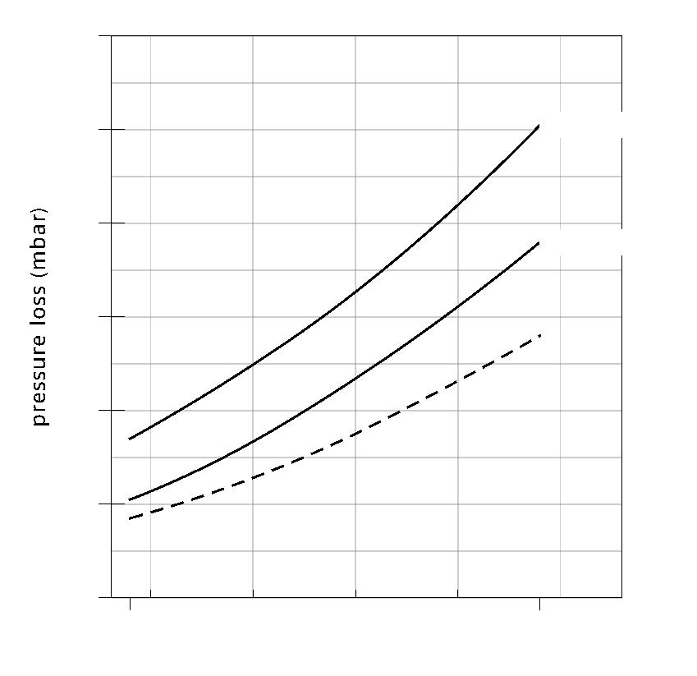Pressure Drop Diagram
The diagrams indicate the minimum pressure drop of the burners with the various gas trains that can be matched
with them; at the value of these pressure drop add the combustion chamber pressure.
The value thus calculated represents the minimum required input pressure to the gas train.
FS5D (NATURAL GAS)
G20 G25
14
20
MBC 65/2
12 MBC 65/2
15
10
MB 405/2
MB 405/2
8
 | 6 |  | MB 407/2  MB 410/2 |  | 10 |  | MB 407/2  MB 410/2
4
5
2
 | 0 |  | 18 58  20 30 40 50 kW |  | 0 |  | 18 58  20 30 40 50 kW
FS5D (LPG)
G31
12
MBC 65/2 10
8
MB 405/2
6
4
2
 | 0 |  | 18 58  20 30 40 50 kW
For pressure levels different from those indicated above, please contact Riello Burners Technical Office.
In LPG plants, Multibloc gas trains do not operate below 0°C.
They are only suitable for gaseous LPG (liquid hydrocarbons destroy the seal materials).
Combustion head + gas train
Combustion head
7
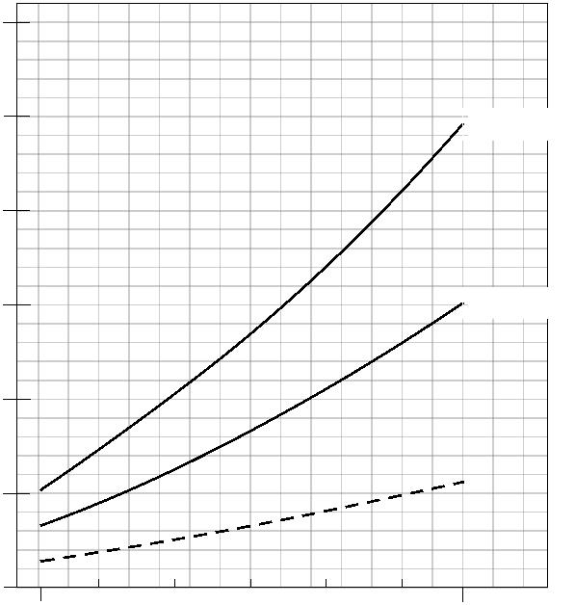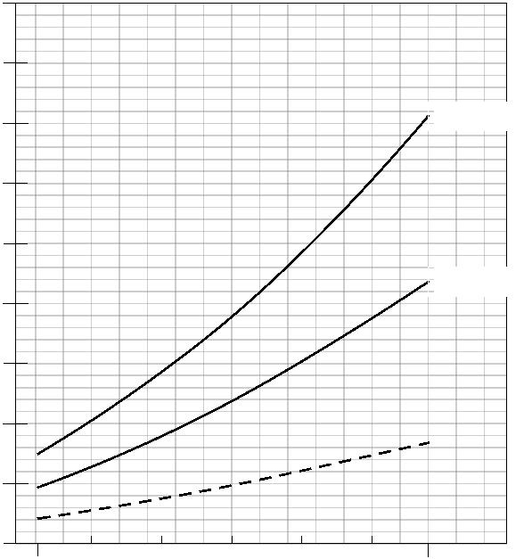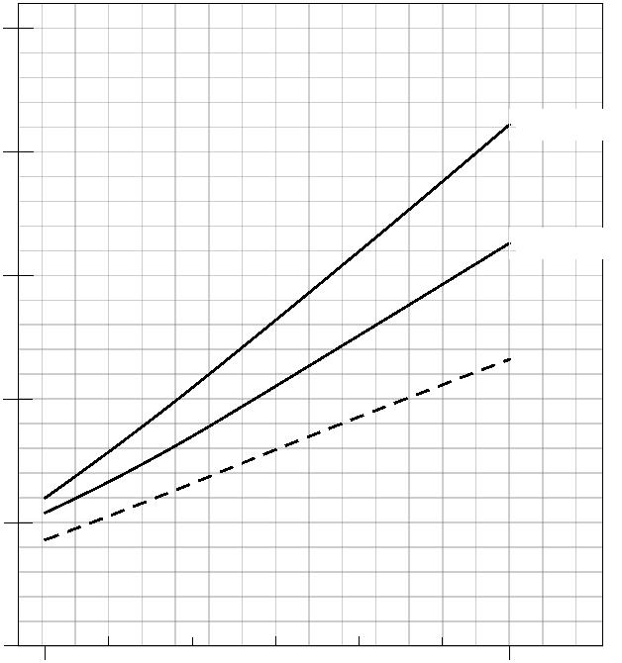Two Stage Gas Burners FSD 5 ÷ 20 Series
FS20D (NATURAL GAS)
G20 G25
45
30
40
25
MB 407/2 MB 407/2
35
30
20
25
15 MB 410/2 MB 410/2
20
15
10
10
5
5
 | 0 |  | 81 220  100 125 150 175 200 kW |  | 0 |  | 81 220  100 125 150 175 200 kW
FS20D (LPG)
G31
25
MB 407/2
20
MB 410/2 15
10
5
 | 0 |  | 81 220  100 125 150 175 200 kW
For pressure levels different from those indicated above, please contact Riello Burners Technical Office.
In LPG plants, Multibloc gas trains do not operate below 0°C.
They are only suitable for gaseous LPG (liquid hydrocarbons destroy the seal materials).
Combustion head + gas train
Combustion head
8
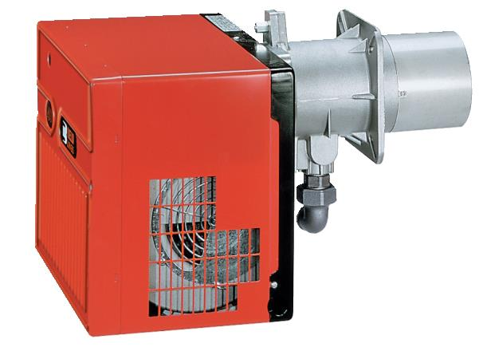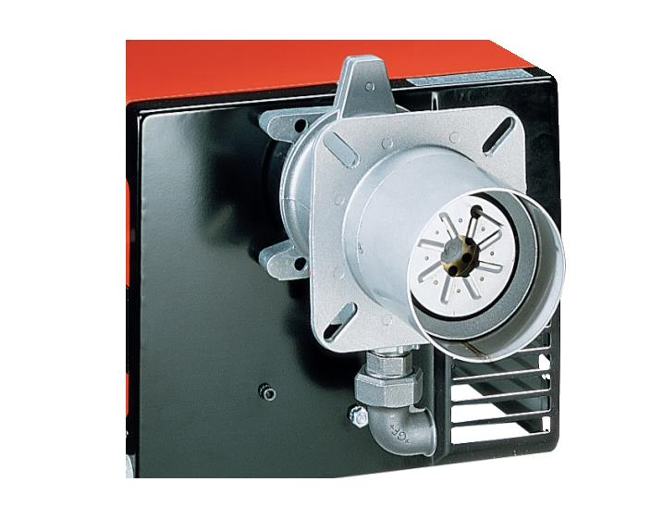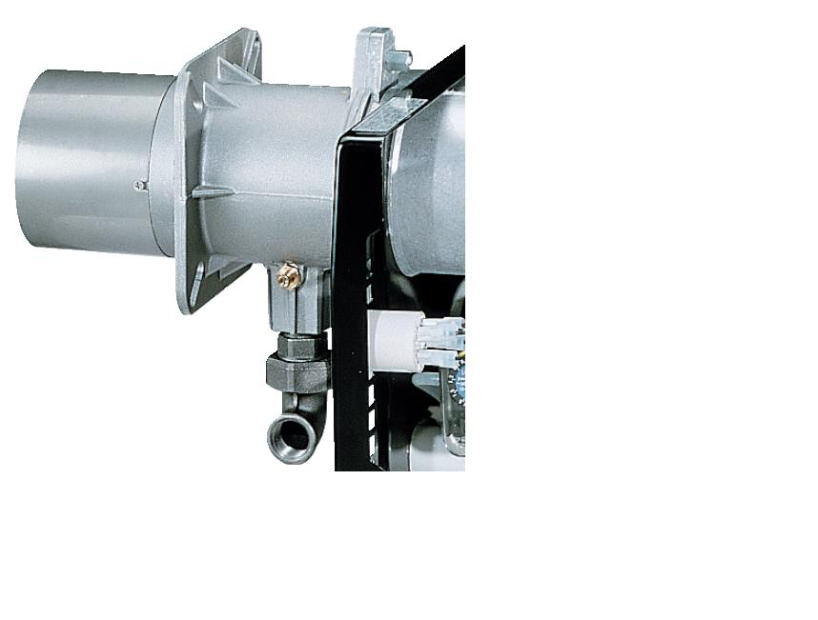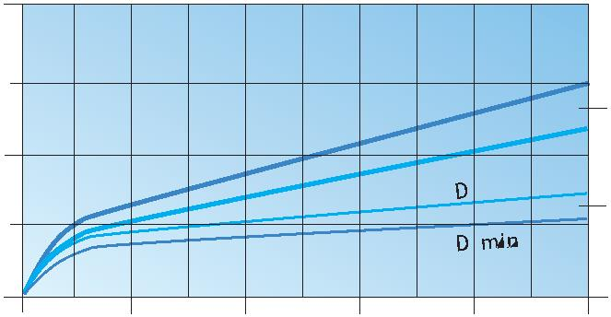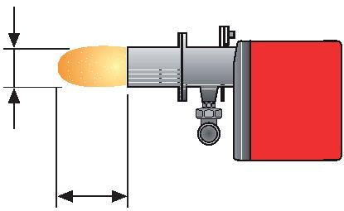Ventilation
The different ventilation circuits always ensure low noise levels with high performance of pressure and air
delivery, inspite of their compact size.
The burners are fitted with an adjustable air pressure switch, conforming to EN 676 standards.
Air suction
Combustion Head
The combustion head in Riello 40 FSD burners is the result of an innovative design, which allows combustion
with low polluting emissions, while being easy to adapt to all the various types of boilers and combustion
chambers.
Simple adjustment allows
the internal geometry of
the combustion head to
be adapted to the burner
output.
Combustion head Mobile flange
DIMENSIONS OF THE FLAME
2
 |  |  | L max |  |  |  | 1 |  | D
 | 1 |  |  | L min
max
L 0,5
 | 0 0  0 100 200 300 400 500  Burner output (kW) |  | Example:  Burner thermal output = 350 kW;  L flame (m) = 1.2 m (medium value);  D flame (m) = 0.6 m (medium value)
9
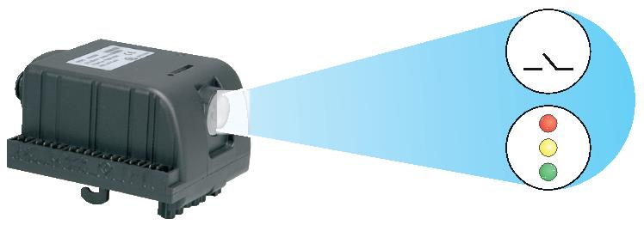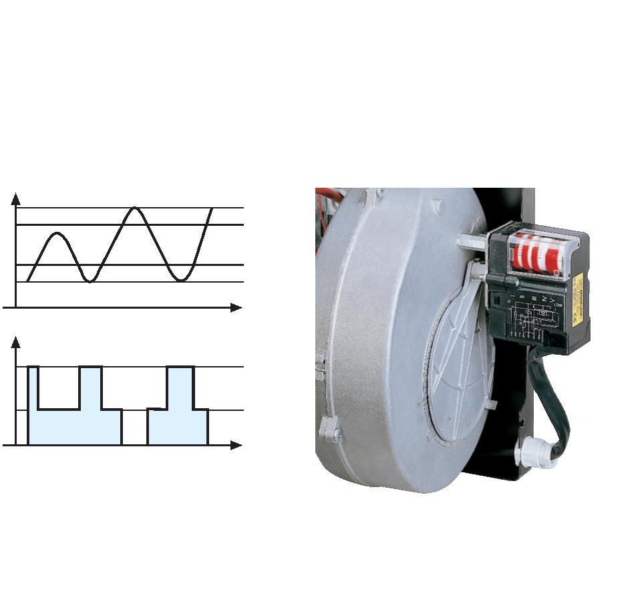Two Stage Gas Burners FSD 5 ÷ 20 Series
Operation
All these models are two stage  operation. |  | °C  bar  1st
The Riello 40 FSD series of two stage  burners allows operating at both full  and reduced output, with consequent  reduction in turning the burner on and  off, their giving better performance to  the boiler. |  |  |  | 2st |  |  |  | ON ON |  |  | time
During stand-by, the air damper is  completely closed (controlled by an  electric servomotor) and prevents heat  loss due to the flue draught. |  |  |  |  |  |  | OFF OFF |  |  |  |  | time
Two stage operation Air damper adjustment
The FS5D model is fitted with the new MG 557 microprocessor control panel. For helping the commissioning and
maintenance work, there are two main elements:
 | Switch |  | The lock-out reset button is the central operating element for resetting the burner control and for  activating / deactivating the diagnostic functions.
The multi-color LED is the central indication element for visual diagnosis and interface diagnosis.
Both elements are located under the transparent cover of lock-out reset button, as showed below.
Switch
10
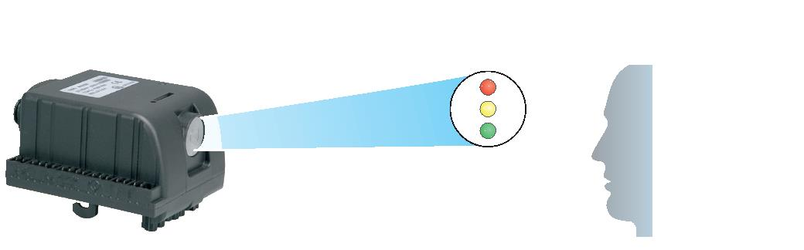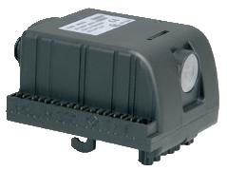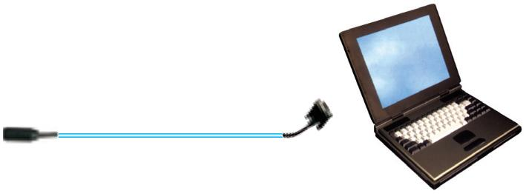There are two diagnostic choices, for indication of operation and diagnosis of fault cause:
- visual diagnosis:
- interface diagnosis:
By the interface adapter and a
PC with dedicated software.
INTERFACE ADAPTER
COMPUTER
Indication of operation:
In normal operation, the various statues are indicated in the form of colour codes according to the table below.
Color code table
Operation status Color code Stand-by Led off
Pre-purging Green
Ignition phase Green
Flame OK Green
Post purge Green
Undervoltage, built-in fuse Led off
Fault, alarm Red
Flame simulation Led off
11
Two Stage Gas Burners FSD 5 ÷ 20 Series
Diagnosis of fault causes:
After lock-out has occurred, the red signal lamp is steady on. In this status, the visual fault diagnosis according
to the error code table can be activated by pressing the lock-out reset button for > 3 seconds.
The interface diagnosis (with adapter) can be activated by pressing again the lock-out button for > 3 seconds.
Example of blinks sequence:
 | Press reset for 3s Interval 2s |  | LED off  RED LED illuminated  LED flashes
Error code table
Signal Possible cause
2 flashes |  | The flame does not stabilise at the end of the safety time:  - faulty ionisation probe  - faulty or soiled gas valves  - neutral/phase exchange  - faulty ignition transformer  - poor burner regulation (insufficient gas)
3 flashes |  | Min. air pressure switch does not close or is already closed before the limit  thermostat closed:  - air pressure switch faulty  - air pressure switch incorrectly regulated
4 flashes Presence of flame:
- in stand-by position after heat demand
- during pre-purging
6 flashes Loss air pressure:
- during pre-purging
- during safety time or operations
7 flashes |  | Loss of flame 4 times during operations after 3 attempts of re-cycle:  - poor burner regulation (insufficient gas)  - faulty or soiled gas valves  - short circuit between ionisation probe and earth  - faulty ionisation probe
12
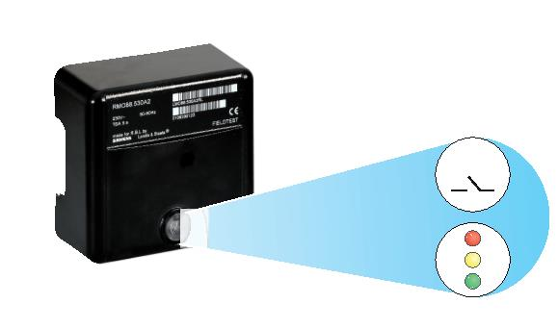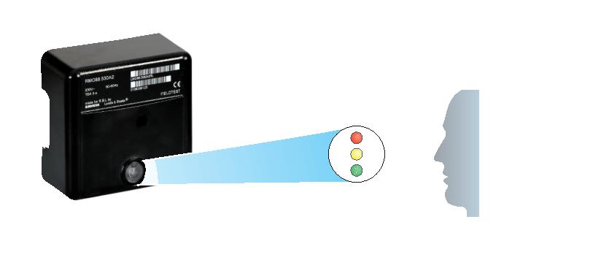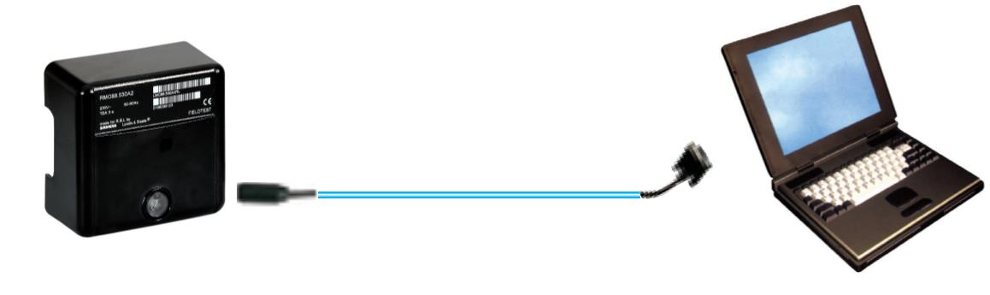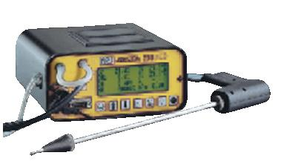The FS20D model is fitted with the new microprocessor control panel for the supervision during intermittent
operation.
For helping the commissioning and maintenance work, there are two main elements:
 | Switch |  | The lock-out reset button is the central operating element for resetting the burner control and for  activating / deactivating the diagnostic functions.
The multi-color LED is the central indication element for visual diagnosis and interface diagnosis.
Both elements are located under the transparent cover of lock-out reset button, as showed below.
Switch
There are two diagnostic choices, for indication of operation and diagnosis of fault cause:
- visual diagnosis:
- interface diagnosis:
 | INTERFACE ADAPTER |  | By the interface adapter  and a PC with dedicated  software or by a predisposed  flue gas analyzer (see  paragraph accessories).
COMPUTER
FLUE GAS
ANALYSER
13
Two Stage Gas Burners FSD 5 ÷ 20 Series
Indication of operation:
In normal operation, the various status are indicated in the form of colour codes according to the table below.
The interface diagnosis (with adapter) can be activated by pressing the lock-out button for > 3 seconds.
Color code table
Operation status Color code Stand-by
Pre-purging
Ignition phase
Flame OK
Poor flame
Undervoltage, built-in fuse
Fault, alarm
Extraneous light
LED off
Diagnosis of fault causes:
After lock-out has occurred, the red signal lamp is steady on. In this status, the visual fault diagnosis according
to the error code table can be activated by pressing the lock-out reset button for > 3 seconds.
The interface diagnosis (with adapter) can be activated by pressing again the lock-out button for > 3 seconds.
The flashes of red LED are a signal with this sequence :
(e.g. signal with n° 3 ﬂashes – faulty air pressure monitor)
LED off
3 sec. 3 sec. 3 sec.
Error code table
Flash code Possible cause of fault
2 flashes |  | No establishment of flame at the end of safety time :  - faulty or soiled fuel valves  - faulty or soiled flame detector  - poor adjustment of burner, no fuel  - faulty ignition equipment
3 flashes
Faulty air pressure monitor
4 flashes
Simulation of flame on burner start up
7 flashes |  | Loss of flame during operation :  - faulty or soiled fuel valves  - faulty or soiled flame detector  - poor adjustment of burner
10 flashes
Wiring error or internal fault
14
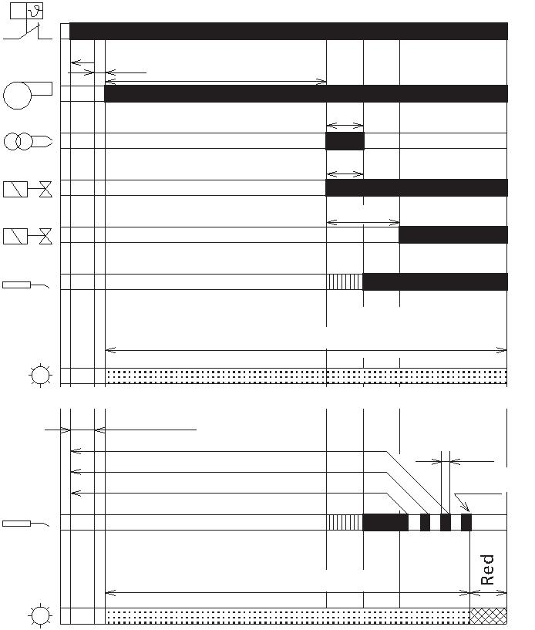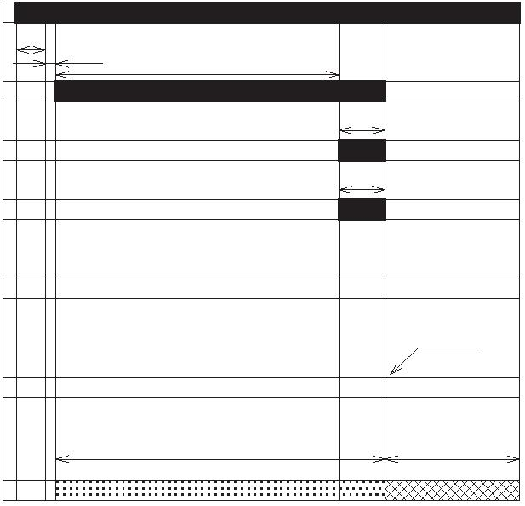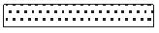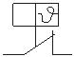START UP CYCLE
Regular operation FS5D
P
KEY TL
t2
t1 I Ignition transformer
t3
 | M  I  V1  V2 |  | M |  | t4i  ts |  | t5 |  | LED Reset button LED indicating operating status  M Fan motor  SO Ionisation probe
  TL Limit thermostat
  V1 1st stage gas valve
V2 2nd stage gas valve
SO
Red (LED signalling)
Green
Green (LED signalling)
LED
 | Flame loss during operation (Recycle max. 3 attempts)  MV = idle |  | No signal needs to be received
t4L
Lo. ckout
SO
Green
LED
Lockout due to ignition failure FS5D
P TL
t2
t1 t3
M M
t4i
I
ts
V1
Red (LED signalling)
Green (LED signalling)
V2
 | SO |  | Lockout KEY  .  I Ignition transformer  LED Reset button LED indicating operating status
M Fan motor Green Red
 | LED |  | SO Ionisation probe  TL Limit thermostat
V1 1st stage gas valve
V2 2nd stage gas valve
Operating times (in seconds)
t1, t3l, t4l, t4a t2l t2, t4i t2a t3 t3a t3r ts t5 t6
max max - - - max max - min/max max
1 30 3 120 40 15 70 3 5/25 360
15
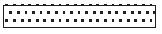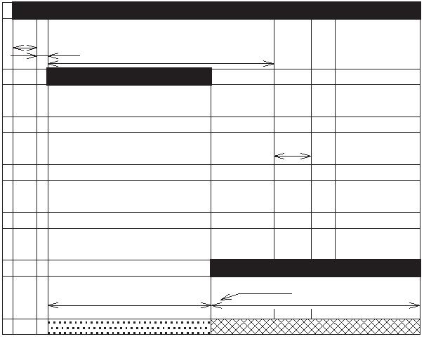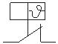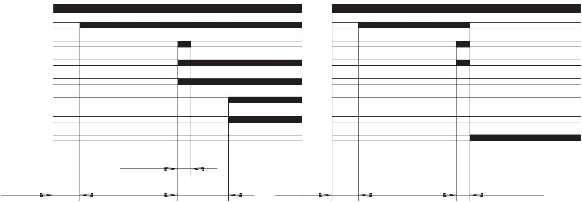Two Stage Gas Burners FSD 5 ÷ 20 Series
Lockout due to a flame or flame simulation FS5D detected during pre-purging
P TL
 | t2 |  | t1 t3
M M
I
ts
V1
Red (LED signalling)
V2
Green (LED signalling)
 | SO |  | Green |  | Lockout  .  Red |  | KEY  I Ignition transformer
LED
LED Reset button LED indicating operating status
M Fan motor
SO Ionisation probe
TL Limit thermostat
V1 1st stage gas valve
V2 2nd stage gas valve
t1, t3l, t4l, t4a t2l t2, t4i t2a t3 t3a t3r ts t5 t6
max max - - - max max - min/max max
1 30 3 120 40 15 70 3 5/25 360
Lockout due to ignition failure FS20D
Normal Lockout due to ignition failure
TL
M
I
V1
F1
V2
F2
LO
max. 3s
max. 2s 40s 10s max. 2s 40s max. 3s
KEY
I Ignition transformer
F1 1st stage flame
F2 2nd stage flame
LO Lockout
M Fan motor
TL Limit thermostat
V1 1st stage gas valve
V2 2nd stage gas valve
16
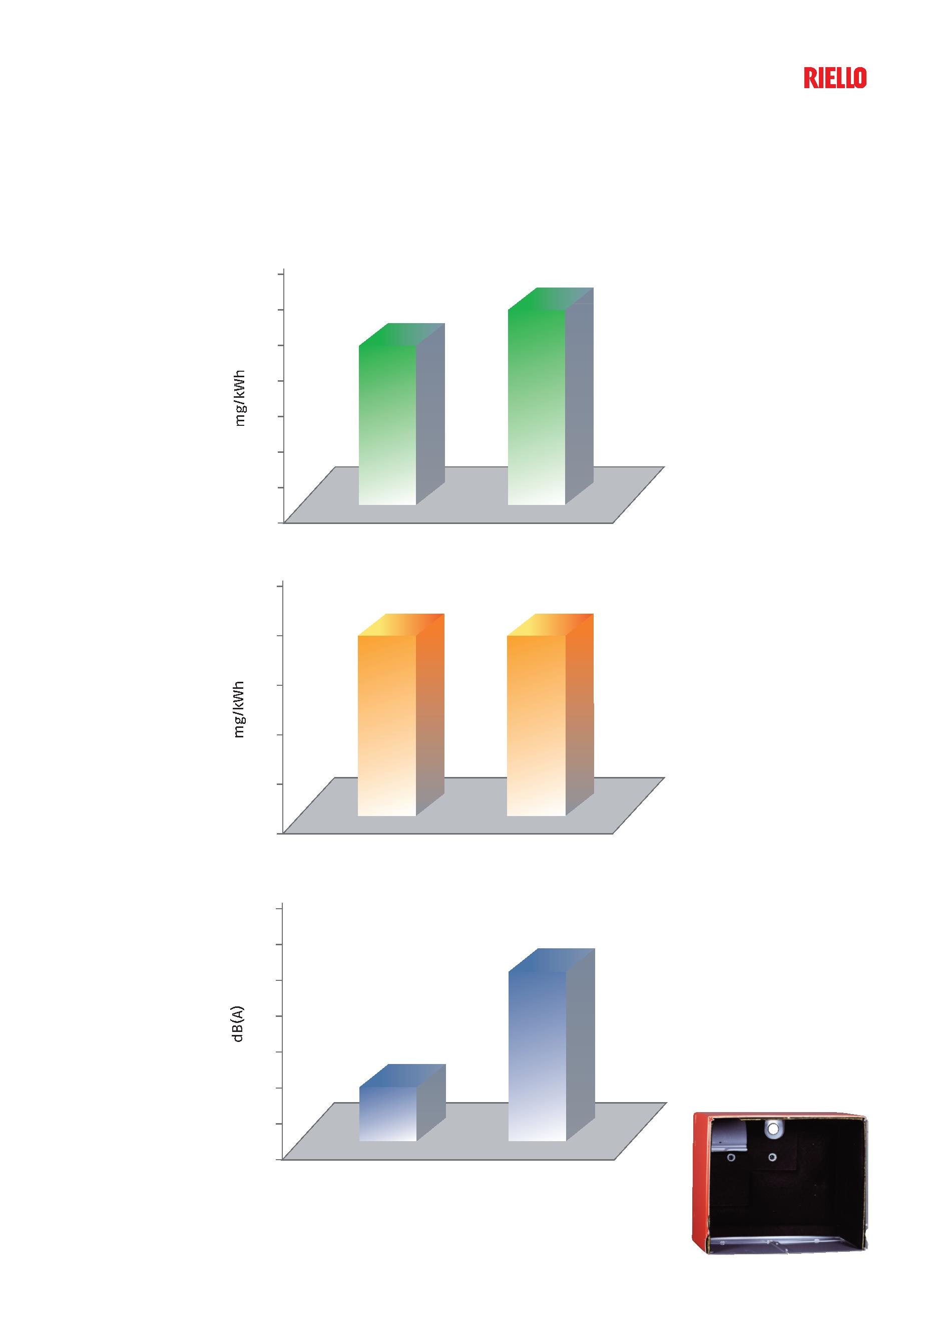Emissions
The emission data have been measured in the various model at maximum output, in conformity with EN 676 standard.
NOx EMISSIONS
120
110
100
90
80
70
60 FS5D FS20D
50
CO EMISSIONS
35
30
25
20
15
FS5D FS20D
10
NOISE EMISSIONS
80
76
72
68
64
60
56 FS5D FS20D
52
Special attention has been paid to noise reduction.
All models are fitted with sound-proofing material inside the cover.
17
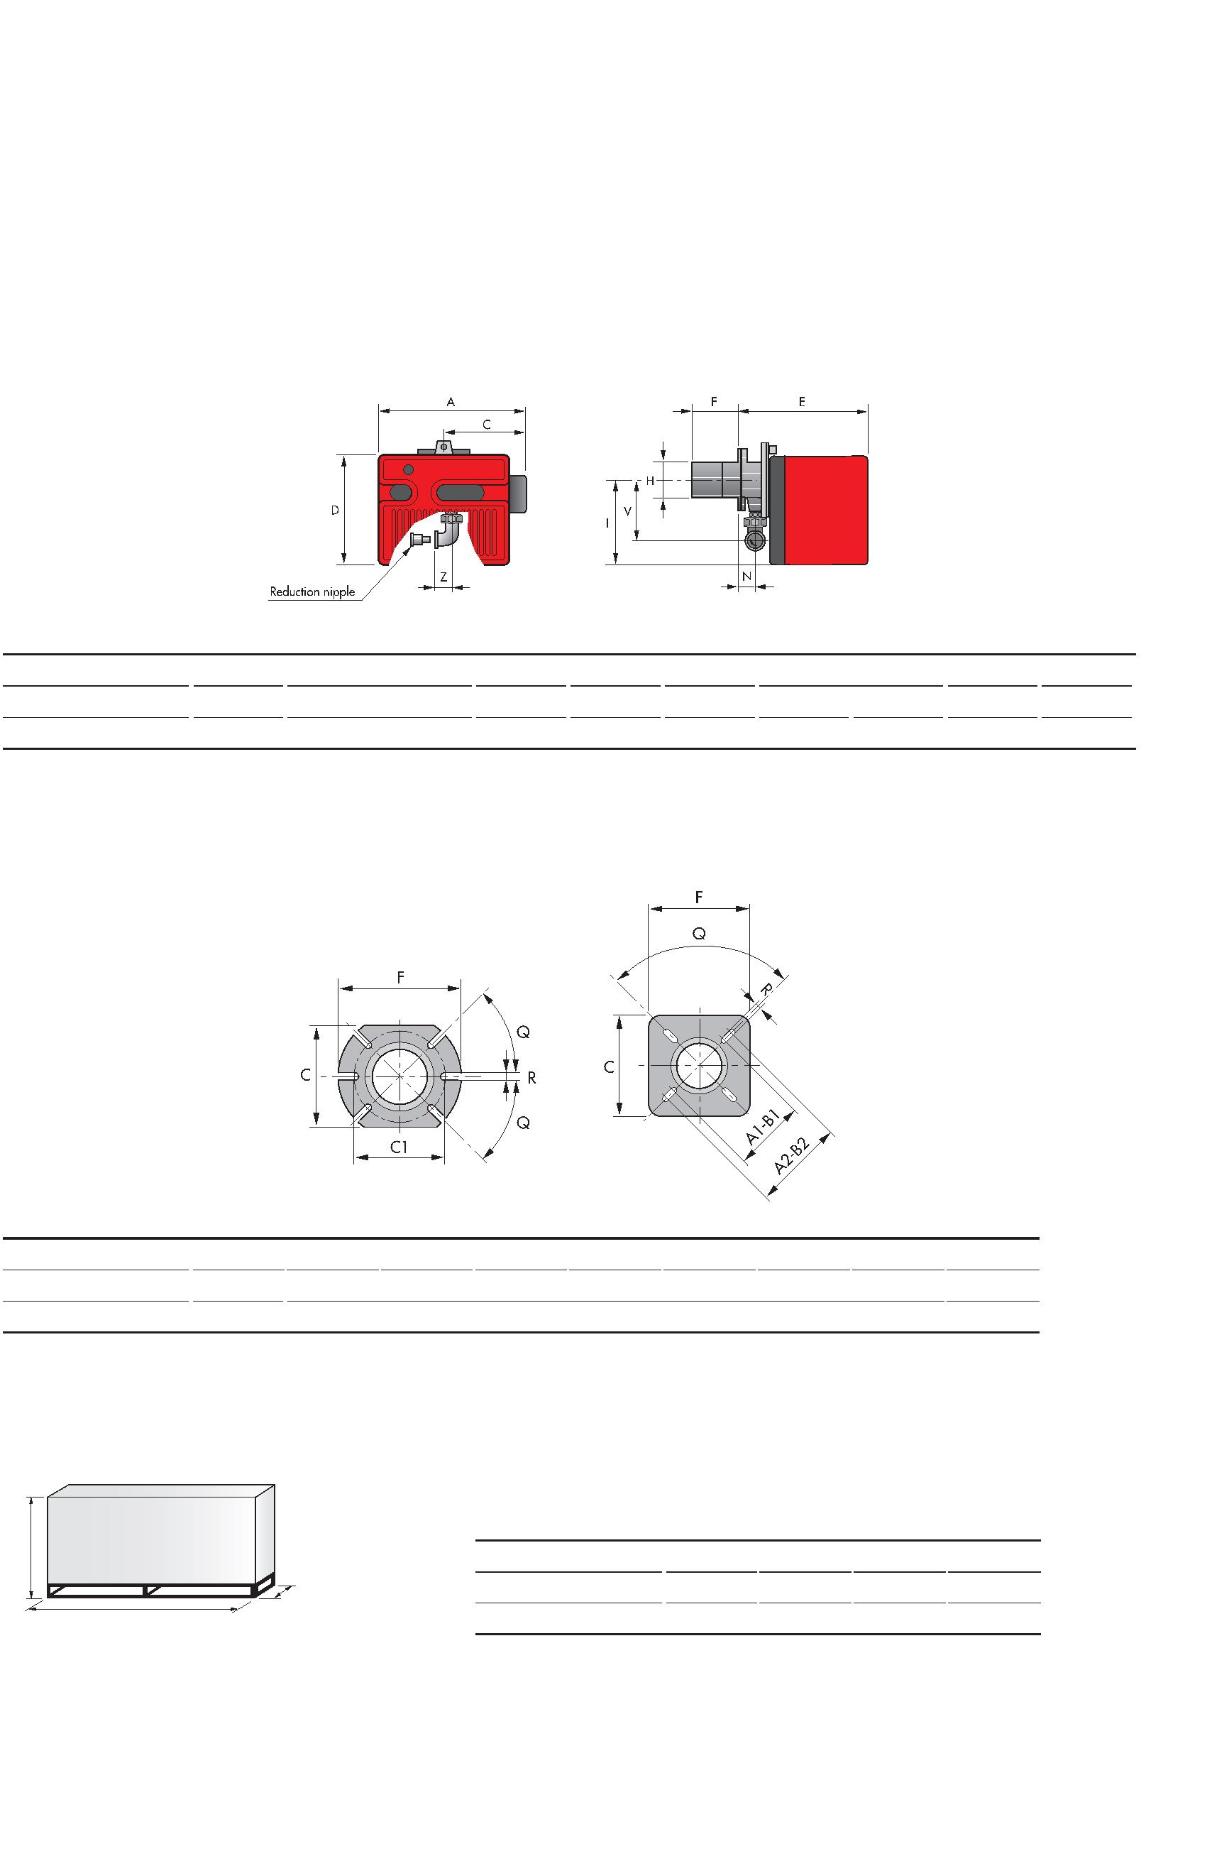Two Stage Gas Burners FSD 5 ÷ 20 Series
Overall Dimensions (mm)
These models are distinguished by their reduced size, in relation to the outputs achieved, which means they can
be fitted to any boiler on the market.
BURNER
MODEL A C D E F H I N V Z
FS5D 306 170 233 295 100 91 180 48 138 28
FS20D 413 238 298 389 120 125 230 67 152 33
BURNER - BOILER MOUNTING FLANGE
FS5D FS20D
MODEL A1 A2 B1 B2 C C1 F Q R
FS5D - - - - 140 130 170 45° 10
FS20D 155 200 155 200 170 - 170 90° 11
PACKAGING
Z
MODEL X Y Z kg
 | X |  | Y |  | FS5D 445 355 325 10  FS20D 535 535 375 20
18
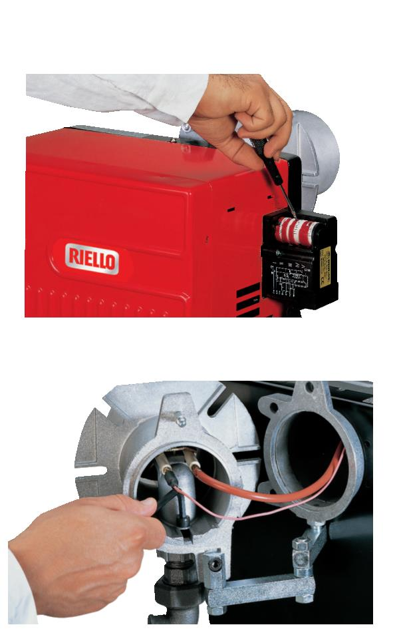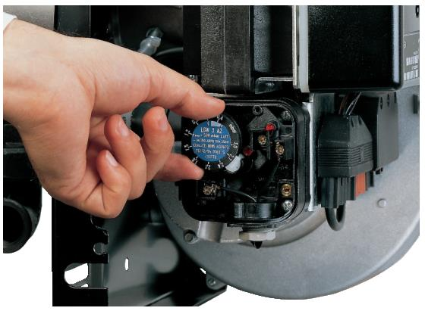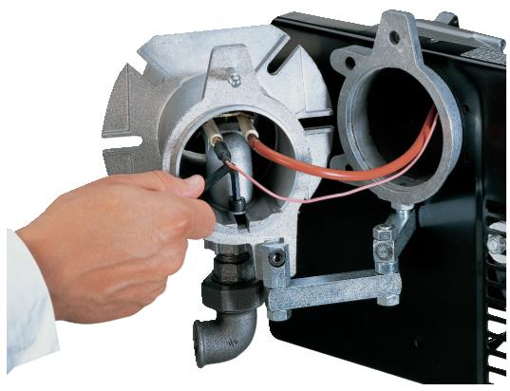Installation Description
Installation, start up and maintenance must be carried out by qualified and skilled personnel.
The burner is set in factory on standard calibration (minimum output), if necessary adjustments can be made on
the basis of the maximum output of the boiler.
All operations must be performed as described in the technical handbook supplied with the burner.
BURNER SETTING
The air damper position is easy to set, and in the FS20D can
be adjusted without removing the burner cover.
Head setting is easy and aided by a graduated scale, a test
point allows reading the air pressure in the combustion
head.
Riello 40 FSD burners are fitted with an air pressure switch
which, in accordance with EN 676 standards, can be
adjusted by the installer using a graduated selector, on the
basis of the effective working conditions.
MAINTENANCE
The maintenance position is easily carried out by hinge that
joins the body of burner to the flange.
19
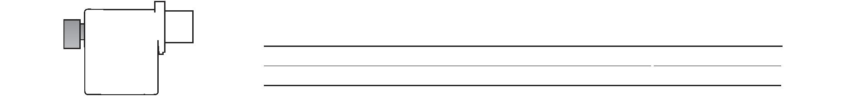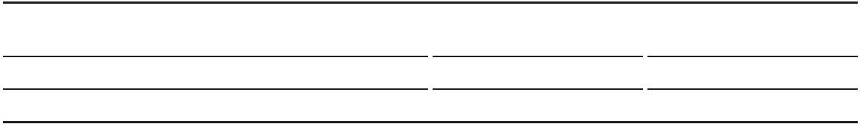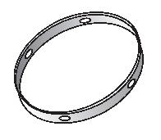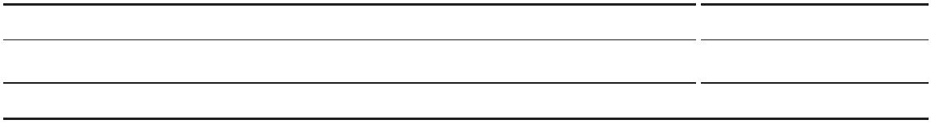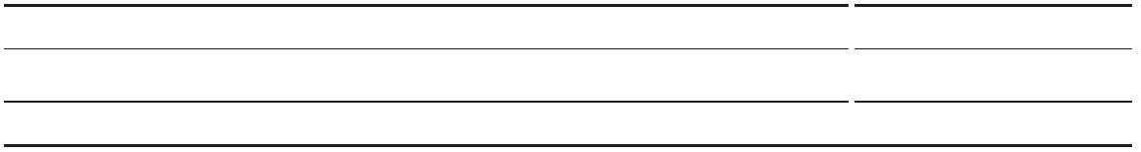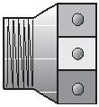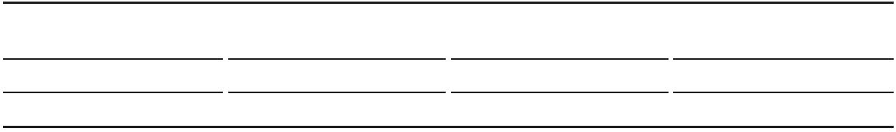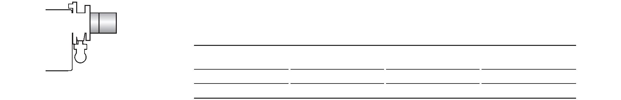Two Stage Gas Burners FSD 5 ÷ 20 Series
Burner accessories
REMOTE RESET CONTROL KIT FOR THE MG 557/3 CONTROL BOX
The MG 557 control box can be remotely released using an electric command kit.
This kit must be installed in conformity with the local authority.
BURNER CODE
FS5D 3002750
EXTENDED HEAD KIT
“Standard head” burners can be transformed into “extended head” versions by
using the special kit. Below the KITS available for the various burners are listed,
showing the original and the extended lengths.
 | BURNER |  | STANDARD HEAD  LENGTH (mm) |  | EXTENDED HEAD  LENGTH (mm) |  | CODE
FS5D 100 125 3000820
FS20D 120 280 3000873
LPG KIT
For burning LPG gas, a special kit is available to be fitted to the combustion head
on the burner, as shown in the following table.
 | BURNER |  | STANDARD HEAD  CODE |  | EXTENDED HEAD  CODE
FS5D 3000882 3000882
FS20D 3000886 3000886
TOWN GAS KIT
BURNER KIT CODE
FS5D 3000889
FS20D 3000894
7-PIN PLUG KIT
If necessary a 7-pin plug kit is available (in packaging of n. 5 pieces).
BURNER CODE
FS5D - FS20D 3000945
20
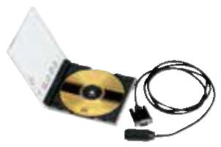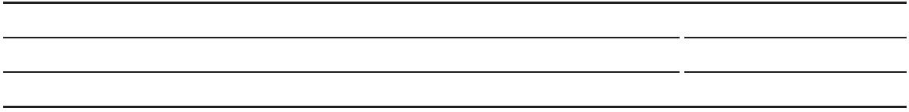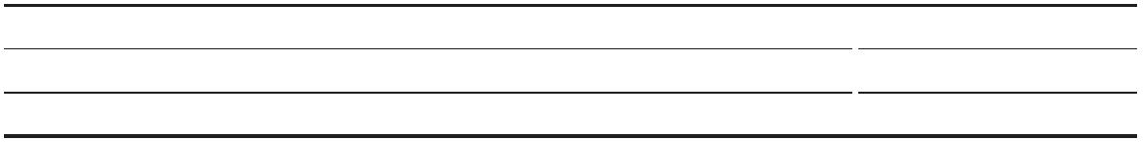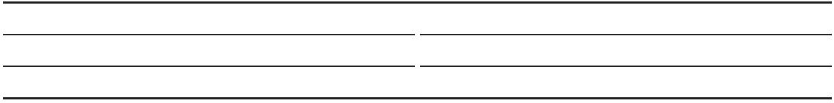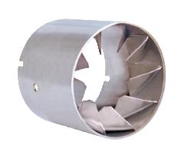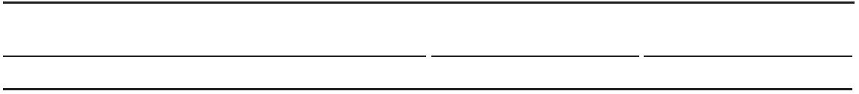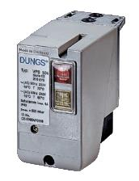END CONE WITH TURBULATOR DISK
The end cone turbolator disk reduces the flame lenght. It is suitable for hoven
application (CO emissions) and short boiler chamber.
BURNER PROJECTION (mm) CODE
FS5D +15 3000916
FS20D +23 3000919
CONTINUOUS VENTILATION KIT FOR RMG CONTROL BOX
If the burner requires continuous ventilation in the stages without flame, a spe-
cial kit is available as given in the following table.
BURNER CODE
FS20D 3010094
PC INTERFACE KIT
To connect the control box to a personal computer for the transmission of opera-
tion, fault signals and detailed service information, an interface adapter with PC
software are available.
BURNER KIT CODE
FS5D 3002731
FS20D 3002719
Gas train accessories
SEAL CONTROL KIT
To test the valve seals on the gas train a special “seal control kit” is available.
 | GAS TRAIN |  | CODE  for 50Hz operation |  | CODE  for 60Hz operation
MB/1 type 3010123 20050030
21
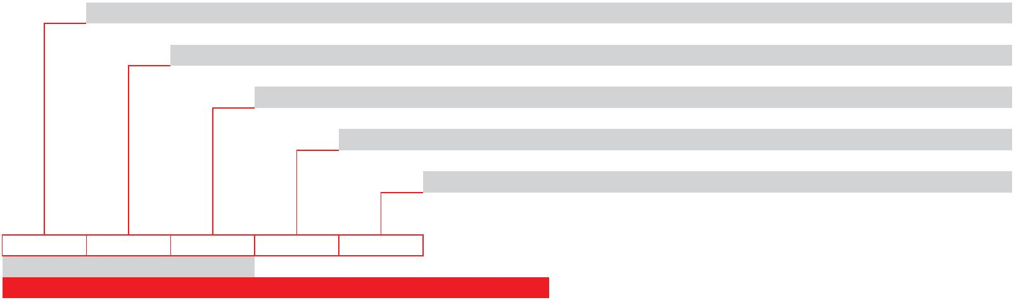Two Stage Gas Burners FSD 5 ÷ 20 Series
Specification
DESIGNATION OF SERIES
A specific index guides your choice of burner from the various models available in the BS series. Below is a clear
and detailed specification description of the product.
Series: F
Fuel: S Natural Gas
Size:
Optional variations: D Two - stage output adjustment
Electrical supply to the system: 1/230/50 1/230V/50Hz
F S 5 D 1/230/50
BASIC DESIGNATION
EXTENDED DESIGNATION
AVAILABLE BURNER MODELS
BURNER MODELS ELECTRICAL  SUPPLY |  | HEAT OUTPUT TOTAL ELECTRICAL  POWER  (kW)  (kW) NATURAL GAS  (Nm³/h) |  | CERTIFICATION NOTE
FS5D 1/230/50 12/23 - 58 1.2/2.3 - 5.8 0.110 CE–0694 CN7805 (1)
FS20D 1/230/50 58/81 - 220 5.8/8.1 - 22 0.250 CE–0694 CN7805 (1)
Net calorific value G20: 10 kWh/Nm³ - Density: 0.71 kg/Nm³
The burners of FSD series are in according to EN 676
(1) With terminal block.
22
SPECIFICATION
STATE OF SUPPLY
Burner
Monoblock, gas burners, completely automatic, with two stage settings fitted with:
- Fan with forward curve blades
- Metallic cover
- Air damper, open in stand by, driven by an electric servomotor
- Air damper with 1st and 2nd stage adjustement
- Single phase electric motor 230 V, 50 Hz
- Combustion head fitted with:
- stainless steel head cone, resistant to high temperatures
- ignition electrodes
- ionisation probe - gas distributor
- flame stability disk
- Adjustable air pressure switch, with graduated selector, to guarantee burner lock out in the case of
insufficient combustible air
- Microprocessor-based burner safety control box MG 557 (with diagnostic, remote reset, continuous purge
integrated, recycle, post-purge)
- IP X0D (IP 40) electric protection level.
Stndard equipment: - Insulating gasket
- Screws and nuts for fixing the flange to the boiler
- Hinge
- Cable grommet
- Instruction handbook for installation, use and maintenance
- Spare parts catalogue.
Conforming to:
- 2014/30 UE Directive (electromagnetic compatibility)
- 2014/35 UE Directive (low voltage)
- 2009/142 EC Directive (gas)
- 2006/42 EC Directive (machine)
- EN 676 (gas burners)
Available accessories to be ordered separately:
- Remote reset control kit for MG 557/3 control box
- Extended head kit
- LPG kit
- Town gas kit
- 7-pin plug kit
- End cone with turbulator disk
- Continuous ventilation kit for RMG control box
- PC interface kit - Seal control kit
23
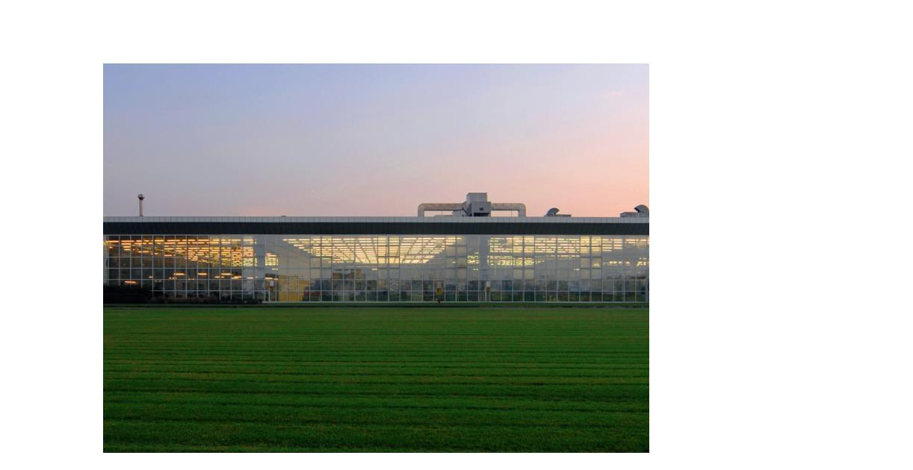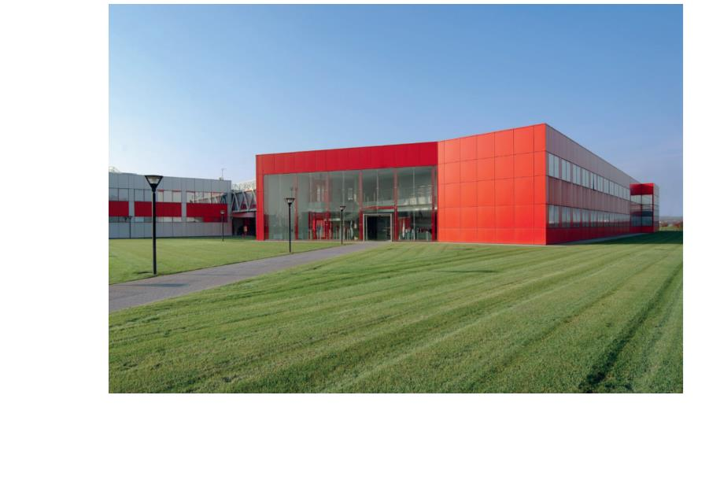Riello Burners a world of experience in every burner we sell.
Across the world, Riello sets the standard in reliable and
high efficiency burner technology.
With burner capacity from 5 kW to 48 MW, Riello gas,
oil, dual fuel and Low Nox burners deliver unbeatable
performance across the full range of residential and
commercial heating applications, as well as in industrial
processes.
With headquarter in Legnago, Italy, Riello has been
manufacturing premium quality burners for over 90 year.
The manufacturing plant is equipped with the most
innovative systems of assembling lines and modern
manufacturing cells for a quick and flexible response to
the market.
[ 1 ]
Besides, the Riello Combustion Research Centre, located in
Angiari, Italy, represents one of the most modern facility
in Europe and one of the most advanced in the world for
the development of the combustion technology.
Today, the company’s presence on worldwide markets is
distinguished by a well-constructed and efficient sales
network, alongside many important Training Centres
located in various countries to meet its customers’ needs.
Riello has 13 operational branches abroad (in Europe,
America and Asia), with customers in over 60 countries.
[ 2 ]
[ 1 ] |  |  | BURNERS PRODUCTION PLANT  S. PIETRO, LEGNAGO (VERONA) - ITALIA
[ 2 ] |  |  |  | HEADQUARTER BURNERS DIVISION  S. PIETRO, LEGNAGO (VERONA) - ITALIA
RIELLO S.p.A. - 37045 Legnago (VR) - Italy
tel. +39 0442 630111 - fax: +39 0442 21980
www.riello.com
Since the Company is constantly engaged in the production improvement, the aesthetic
and dimensional features, the technical data, the equipment and the accessories can be
changed. This document contains confidential and proprietary information of RIELLO S.p.A.
Unless authorised, this information shall not be divulged, nor duplicated in whole or in part.

